# Computational Domain

Figure 3.1(a)

Computational domain was chosen to be of axisymmetric type and is generated using ANSYS ICEM CFD 16.1 software. It was meshed with structured, non uniform grid. Since the geometry was a simple one it was meshed using hexahedral elements. Meshing was done using the blocking strategy of ANSYS ICEM CFD software. A block was created covering the entire domain and unnecessary portions of block were removed which allowed the blocks to associate with the respective portions of the geometry. A hierarchy of four, quasi 2D type, meshes was generated with each mesh refined, by a factor half in each direction, compared to their latest coarser mesh.

Initially meshes were generated as 2D radially symmetric meshes, since ANSYS CFX works only with 3D meshes; a small change was made in the meshes. At the time of reading the meshes in to the ANSYS CFX Pre processor, the 2D meshes were extruded by rotating them by 5 degrees in circumferential direction, with one cell in the circumferential direction. Hence a quasi-2D mesh, having hexahedral as well as wedge elements in it, is generated. The expansion ratio of the meshes was controlled to be < 1.2, in order to have a denser mesh in the region behind the bluff body and in the near field. Mesh was gradually made coarser towards the exit and towards the top as no significant physical changes would be taking place there.

In order to save the unnecessary computation time and resources, jet flow pipe was not considered in the computational domain. Instead a precursor simulation was carried out for the jet inlet pipe. The inflow conditions for the propane jet inlet were provided from the fully developed pipe profile obtained from the precursor simulation of the fuel jet pipe.

The computational domain for the precursor simulation was a thin long pipe, which extended 50D, D=0.52 cm, in the axial direction (X-axis) to have a fully developed pipe flow, as in the experiment [3]. The computational domain for precursor simulation was also of axisymmetric type, with quasi-2D mesh.

Figure 3.1(b) shows the different mesh resolutions to have a visual comparison between them.

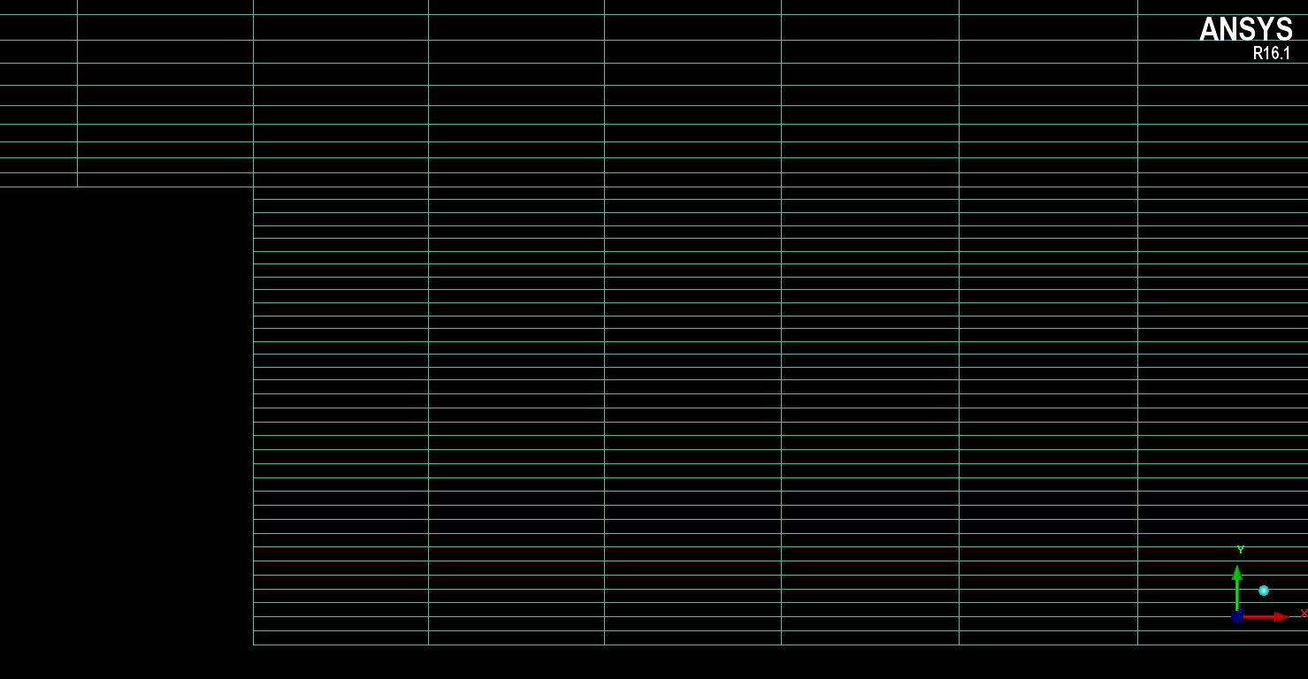

**Mesh 2**

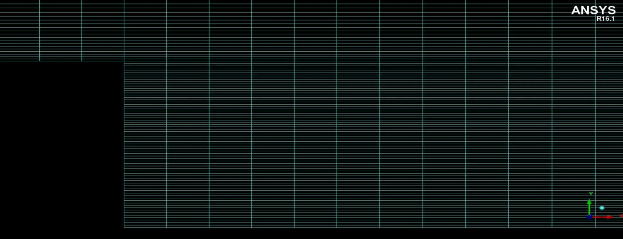

**Mesh 3**

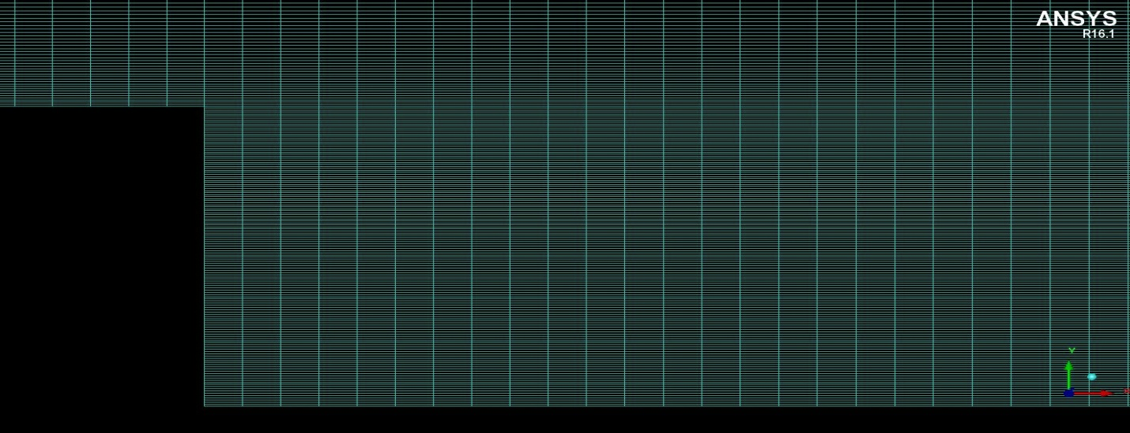

**Mesh 4**

Figure 3.1(b)

The mesh quality plays an important role for the solver to deliver more accurate and faster results. Bad mesh quality can cause the solver to diverge and even deliver inaccurate results. Meshes generated here are of good quality because of the following reasons:

1. The changes in the mesh spacing is continuous over the whole domain, specifically in the region behind the bluff body, where important phenomenon viz. recirculation zone, turbulent mixing between jet and co-flow would take place
2. Aspect ratios in the important regions should be between 20 to 100 as specified in [14]
3. Minimum face angle which should be between (20 < Min Angle < 160) [11]

Table 3 shows the details about the mesh parameters.

|  |  |  |  |  |
| --- | --- | --- | --- | --- |
| Parameter | Mesh 1 | Mesh 2 | Mesh 3 | Mesh 4 |
| Number of nodes | 3736 | 15568 | 63532 | 256660 |
| Number of element | 7665 | 31530 | 127860 | 514920 |
| Minimum grid angle | 90 | 90 | 90 | 90 |
| Maximum aspect ratio | 22.57 | 24.54 | 25.59 | 26.52 |

Table 3